WOW! Overwhelming Success!
Upcoming Events
•••
Staff Professional Development Day
Friday, March 10th
NO SCHOOL FOR STUDENTS
•••
Ventana’s 5th Annual FESTIVAL of STORIES
& Hicklebee’s Book Fair
March 13th – 17th
•••
Family/Community Storytelling Event
Wednesday, March 15th
4:30 – 6:30 PM
•••
Teacher Appreciation Week
March 27th – 31st
•••
Coffee & Conversation
Thursday, April 6th
8:30 – 10:00 AM
•••
CCLA Annual Seder Dinner
Thursday, April 13th
Parish Hall
5:30 – 7:30 PM
•••
Spring Break
April 10 – 14th
School Closed
•••
Easter Egg Hunt
Sunday, April 16th
11:30 AM – 1:00 PM
•••
Annual Ventana Spring Social & Auction
Saturday, April 29th
6:00 – 10 PM
  - Volume 2016-17
  - Issue 27
March 10, 2017
A weekly publication by your Head-of-School
Also available on the Ventana School website.

Keeping You Informed
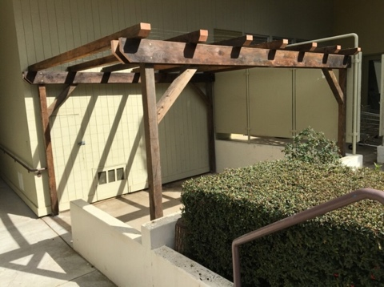
Our recent Family Volunteer/Work Day was an unmitigated success! Projects large and small were accomplished in record time. We are thrilled by the results.

Our exterior “Reggio” look is – at long last - taking shape. The pergola structure awaits its plantings. The preschool playground has a new cobblestone river and many new plantings.

We wish to thank the many families who came out on Saturday to lend a hand and to, ‘literally,’ build our community. Thanks, too, to many of our Ventana children who provided helping hands.
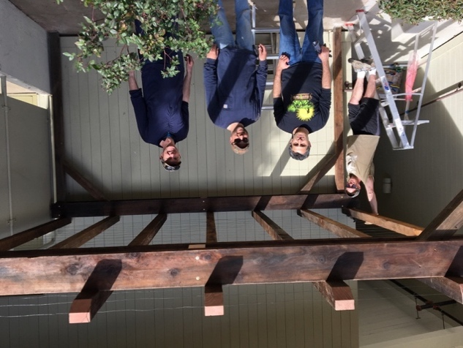
Special gratitude is extended to Martin Campanella for his design and build expertise around the addition of our “Winter Room” pergola. Also, ‘hats off’ to his affable team: Manuel Oliver, Yazdan Aghaghiri, Brian Hill, and Paul Vinger. [Pictured left.]

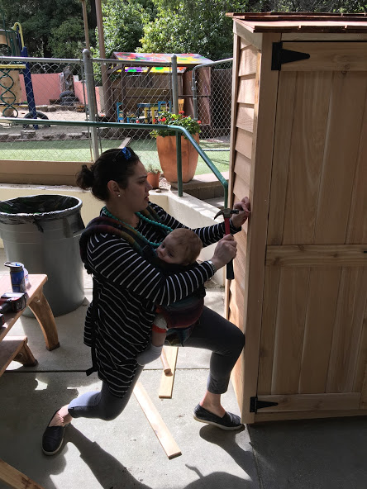

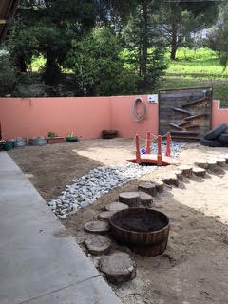
Other able-bodied assistance was rendered by Eric and Karen Gordon, Andrea Campanella, Jenny Warilla, Dave Hong, Jackie Tsao and Chris Kohl, Miha and Marc Zelzer, Kenji Kaneda, Mark and Layla Holveck, Molly Anderson, Alyson Abrego, and Kim Nave. Thanks, too, to Isabella Hill and Yesi Guizar for organizing the day, and to an anonymous donor who provided funding for materials. Again, a hearty THANK YOU to all who came out and donated time and effort to the beautification of our wonderful school. It does truly take a village.

Design Thinking Workshop TONIGHT
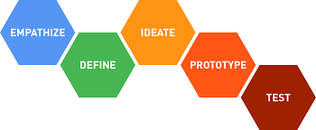
Tonight’s Parent Education offering will be a reprise of a Design Thinking Workshop offered nearly 2 years ago. Join Rick Murphy, Ventana’s STEM Teacher and Marcy Barton, Ventana’s Head of School tonight - Thursday, March 9th - as they walk you through this extraordinary process. Participants will experience the 5-step process inspired by the Stanford Design School, then participate in hands-on application. Discussion of the breadth of applicability for this practice will be featured. Although the workshop is geared toward adults, school-age children accompanied by a parent are more than welcome to attend.

5th Annual Hicklebee’s Book Festival

The 5th Annual Ventana Book Festival is here! Next week - March 13th -17th - the week-long event celebrating writing, reading, and storytelling and a Hicklebee’s (pop-up) Book Sale in the Parish Hall is set to begin. Various school-wide and community activities scheduled for the week include:
• a used book drive to benefit Reading Partners
• a browseable, ‘pop-up’ book store located in the Parish Hall
• mystery readers in every classroom
• publishing parties and dramatic readings
• several dress-up days including favorite storybook character day, and (of course) the HIGHLIGHT…
• the Festival of Stories with Joel Ben Izzy; storyteller, traveler, and the author of "The Beggar King and the Secret of Happiness" who will be on campus ALL DAY, Wednesday, March 15th.

This Festival is always a fun-filled week, boasting various opportunities for children to interact with books, stories, and authors in new and exciting ways! Tickets for the author event portion of the festival on Wednesday, March 15th at 4:30 PM are available at http://tinyurl.com/ventanastoryfestival2017. Get yours today.

Buddy Family Project
As we prepare to welcome many new families into our Ventana community, we are seeking current families who might be willing to engage as a “buddy family” to the newcomers. We will attempt to pair current and new families having similar age or grade level children, so that families can experience comfortable commonalities. It is hoped that families can share activities, plan play dates or joint family outings, communicate information about the comings and goings at Ventana, and introduce the new family to other Ventana community members.
We expect to fire-up this family collaboration in late-May of this year. This provides plenty of time to get acquainted before the busy summer season begins. If this sounds like a good idea to you, and if you are interested in becoming a Buddy Family, please check in with Yesi in the Ventana office. yesi@ventanaschool.org And THANK YOU for helping us to build our Ventana community.

Notes and Reminders
• Off to Reggio Emilia: It is with great pleasure that we announce that two members of our faculty will be traveling to Reggio Emilia, Italy for the annual International Study Group sponsored by Reggio Children. The trip, from April 2nd through the 7th, is being made possible through a generous contribution from an anonymous donor. Kim Nave and Julie Kelsey will be attending the week-long conference at the Loris Malaguzzi Center in Reggio Emilia where they will be meeting with Reggio luminaries and fellow educators from around the world. We know that this extraordinary experience will enhance their teaching repertoire and expand their notion of Reggio philosophy. We expect that they will bring back with them fuel for site-based professional development in the fall that will foment an invigorated dedication to our work with your extraordinary children. In their absence, curriculum will be followed, lessons will be prepared and delivered, as a stand-in teacher will convene each class.

• Our April 13th Education Connect Event: SEL & Ventana Values is cancelled. The school will be closed for Spring Break at that time.

• Late Pick-up: Parents and care givers are reminded to arrive on time for mid-day (preschool) pick-up. Preschool teachers are expected to be engaged in daily planning and/or participating in school meetings on or before 12:40 PM every day. Late pick up puts these professionals in the difficult a position of having to be in two places at once. Thank you for your understanding and cooperation.

• Enrichment Classes Final Session: Ventana’s 4th Enrichment Session will begin on March 20th and is now available for purchase. The link was sent to your email inbox March 3rd. Please visit the Extended Day blog, or send an email to WendyB@VentanaSchool.org for more information.

• Closing thoughts after a wondrous week of building; of moving Ventana’s grand experiment called Reggio education forward:
“I want to be around people who do things. I don’t want to be around people anymore who judge or talk about what people do. I want to be around people who dream. And support. And do things.” – Amy Poehler

Thank you to our parent dreamers and supporters who are moving us closer to becoming that beacon of culture and learning to which we aspire.

